**Increased forest carbon storage with increased atmospheric CO2 despite nitrogen limitation: A game-theoretic allocation model for trees in competition for nitrogen and light**

**Authors:** Ray Dybzinski\*, Caroline E. Farrior, and Stephen W. Pacala

**Appendix S2 – Nitrogen Cycling Model Modification: Accounting for effects of nitrogen storage in wood on the net nitrogen mineralization rate, allocation, and carbon storage**

Our model's tractability is owing in part to the simplification demonstrated by Dybzinski et al. (2011), whereby a full nitrogen cycling model may be simplified to a constant nitrogen mineralization rate that is primarily a function of the size of "slow" pool of soil organic nitrogen (i.e. relatively slow to decompose) and its decomposition rate (see their Appendix G). We use only this constant nitrogen mineralization rate in the main text model and do not explicitly include a soil organic nitrogen pool or nitrogen cycling. However, a calculation of nitrogen storage using the nitrogen concentrations in foliage, wood, and fine root NPP together with their residence times (i.e. parallel to the carbon storage equations, Eqs. 1 – 4) shows that more nitrogen is stored in living trees in the model under eCO2 as compared to aCO2 (Fig. S3a,b). This is entirely due to increased nitrogen storage in wood alone, as predicted nitrogen storage in foliage and fine roots actually decreases slightly under eCO2 (Fig. S3c). In reality, if more nitrogen is stored in wood, that should leave less nitrogen stored in soil, which should decrease the net nitrogen mineralization rate, all else equal. But because the main text model does not explicitly include nitrogen cycling, there is no consequence for this increased nitrogen storage (i.e. the nitrogen mineralization rate is unaffected). Here we ask, does the influence of competitive ESS allocation on the nitrogen mineralization rate decrease NPP and thus reduce, negate, or even reverse the carbon storage prediction of the main text model via progressive nitrogen limiation?

*Nitrogen cycling model modification*

In this appendix, we modify the model by explicitly including total soil organic nitrogen, which, together with total tree nitrogen, approximates total nitrogen in a closed system. We assume that nitrogen storage in these two pools, soil and tree, is zero sum; more nitrogen stored in trees means less stored in soil and vice versa. Instead of prescribing the nitrogen mineralization rate, as in the main text model, this modified model calculates the nitrogen mineralization rate as proportional to total soil organic nitrogen, which causes the nitrogen mineralization rate to decrease as more nitrogen is stored in wood under eCO2. We use this "nitrogen cycling model modification" to verify that increased nitrogen storage in wood under eCO2 does not seriously compromise the conclusions we draw from the main text model.

The modified model is identical to the main text model presented in Appendix S1 except that *N*, the net nitrogen mineralization rate, is now

|  |  |
| --- | --- |
| $N=Sd$, | (S49) |

where *S* is the soil organic nitrogen pool (gN m-2) and *d* is the rate at which it is converted to mineral (i.e. plant available) nitrogen (yr-1). Because the soil organic nitrogen pool and the tree nitrogen pool are zero sum, for a forest in dynamic equilibrium we can express *S* as

|  |  |
| --- | --- |
| $S=T-\frac{1}{μ}ωW^{*}-λML^{*}-\left(σ+ρ^{*}\right)R^{*}$, | (S50) |

where *T* is the total system nitrogen, 1/*μ* is the residence time of nitrogen in wood (77 yr), *ω* is the N:C ratio of wood (0.0024 gN gC-1), and *W*\* is ESS wood NPP, making the second term on the RHS the nitrogen content of standing wood. In addition, *λML\** is the nitrogen content of standing foliage and (*σ + ρ*)*R\** is the nitrogen content of standing fine root biomass. However, the main text model predicts little change in foliage and fine root nitrogen storage under eCO2 (Fig. S3c) and thus

|  |  |
| --- | --- |
| $$\frac{d\left(\frac{1}{μ}ωW^{*}\right)}{d{CO}_{2}}≫\frac{d\left(λML^{*}+\left(σ+ρ^{*}\right)R^{*}\right)}{d{CO}_{2}}$$ | (S51) |

for these parameter values. Moreover, the foliage and fine root pools combined never constitute more than 5% of total system nitrogen in the temperate and boreal forest data of Cole and Rapp (1981) (Fig. S4d). Thus, we approximate *S* without these pools to improve model tractability,

|  |  |
| --- | --- |
| $S≈T-\frac{1}{μ}ωW^{*}$, | (S52) |

while still allowing us to address the question at hand: will increased nitrogen storage by trees under eCO2 (which occurs due to increased wood NPP, Fig. S3) seriously compromise the conclusions we draw from the main text model?

To choose reasonable values for *T* and *d*, we draw on data collected from mostly boreal and temperate forests from around the world under the International Biological Programme, as reported in Cole and Rapp (1981). Mean nitrogen in trees is 56 gN m-2 (Fig. S4a), whereas mean nitrogen in soils is 698 gN m-2 (Fig. S4b). The fraction of total system nitrogen in trees has a mean of 0.07 and is at most 0.14 (Fig. S4c). With the exception of one outlier (3500 gN m-2), the range of total system N extends from ~100 to ~1000 gN m-2. We use this range and select a value for *d* (0.0167 yr-1) that, when multiplied by this range of soil N, generates the range of net nitrogen mineralization rates used in the main text model (Fig. S5b).

*Modified model results and discussion*

As in the main text model (Fig. S3), the nitrogen stored in trees increases under eCO2 and thus becomes a larger fraction of total system nitrogen (Fig. S5a). Accordingly, the net nitrogen mineralization rate decreases (Fig. S5b), which in turn reduces the increase in productivity due to eCO2 (relative to the main text model) and causes slight adjustments in competitive allocation (Fig. S6, left-hand panels). These modifications in turn reduce ** and ** relative to the main text model (Fig. S6b, d), which in turn reduce absolute carbon storage and relative carbon storage relative to the main text model (Fig. S6f and Fig. S7).

The results of the modified model indicate that increased nitrogen storage in wood under eCO2 and the subsequent decline in the net nitrogen mineralization rate that it causes, i.e. progressive nitrogen limitation, will diminish the increase in carbon storage under eCO2. However, the magnitude by which it is diminished is not large because the differential fraction of nitrogen that is removed from the soil pool is small (Fig. S5a).

In one respect, this analysis may be conservative because our simple method of parameterization for *T* and *d* led to a larger fraction of total nitrogen in trees (Fig. S5a) than was observed in the data (Fig. S4c), making the differential fraction of nitrogen that is removed from the soil pool larger than it might be in reality. Thus, a better accounting of nitrogen cycling may not differ from the main text results to the extent presented here. On the other hand, some of the soil organic nitrogen measured in the data (Fig. S4b) may be bound to highly recalcitrant soil organic matter. At the extreme, such nitrogen may not take part in nitrogen cycling at ecologically-meaningful timescales, which would mean that, although measured, such nitrogen is not really part of the cycling system. To the extent that such "ghost" nitrogen exists, tree nitrogen becomes a larger fraction of the total cycling nitrogen, which further decreases the nitrogen mineralization rate due to increased nitrogen storage in trees under eCO2.

In summary, the results of this modified model and their implication for the conclusions drawn from the main text model seem clear: the smaller the fraction of total cycling nitrogen that is stored in trees, the closer the main text approximation becomes, and vice versa. Existing evidence suggests that only a small fraction of system nitrogen is stored in trees (Fig. S4), supporting the results of the main text model.

**References**

Cole DW, Rapp M (1981) Elemental cycling in forest ecosystems. In: *Dynamic properties of forest ecosystems.* (ed Reichle DE) pp 341-409. London, International Biological Programme 23. Cambridge University Press.

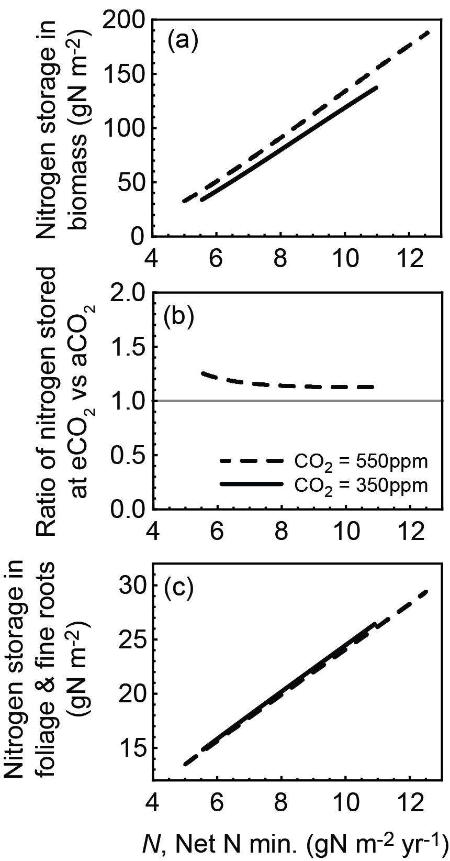

Figure S3. Main Text Model: Nitrogen storage expressed in either absolute (a) or relative (b) terms increases under eCO2 in the main text model as a consequence of increased wood production (which has a long residence time). Because both foliage NPP and fine root nitrogen concentration decrease slightly under eCO2, nitrogen storage in foliage and fine roots (c) is almost unchanged under eCO2. Thus, all of the additional nitrogen storage is in wood.

gcb12783-sup-0005-Figure_S4.tif

Figure S4. Distributions of nitrogen pools in trees (a) and soils (b) and expressed as the fraction of total system nitrogen (tree nitrogen plus soil organic nitrogen) in trees (c) and in only foliage + roots (d). Data are from the International Biological Programme forest study as reported in Cole and Rapp (1981). Tree nitrogen is the sum of overstory foliage, branch, bole, and root nitrogen. Soil organic nitrogen is the sum of forest litter layer and "soil rooting zone" nitrogen. Sample sizes are 24 (a), 25 (b), 18 (c), and 18 (d) (some sites are missing some components, hence the differences in sample sizes). One site is Mediterranean, four are boreal, and the remainder are temperate. Of the temperate sites, approximately one third are dominated by conifers, whereas the remainder are dominated by angiosperms. Panel (b) does not show one outlier site with soil organic nitrogen = 3500 gN m-2.

gcb12783-sup-0006-Figure_S5.tif

Figure S5. Nitrogen Cycling Model Modification: Under elevated CO2 (dashed lines) as compared to ambient CO2 (solid lines), a greater fraction of total system nitrogen is stored in trees (a) due to the increased NPP of wood and its correspondingly longer retention time. As a result, the soil organic nitrogen pool decreases slightly (not shown), which in turn decreases the nitrogen mineralization rate, all else equal (b). In the main text model, the dashed and the straight lines of (b) would be exactly the same by assumption.

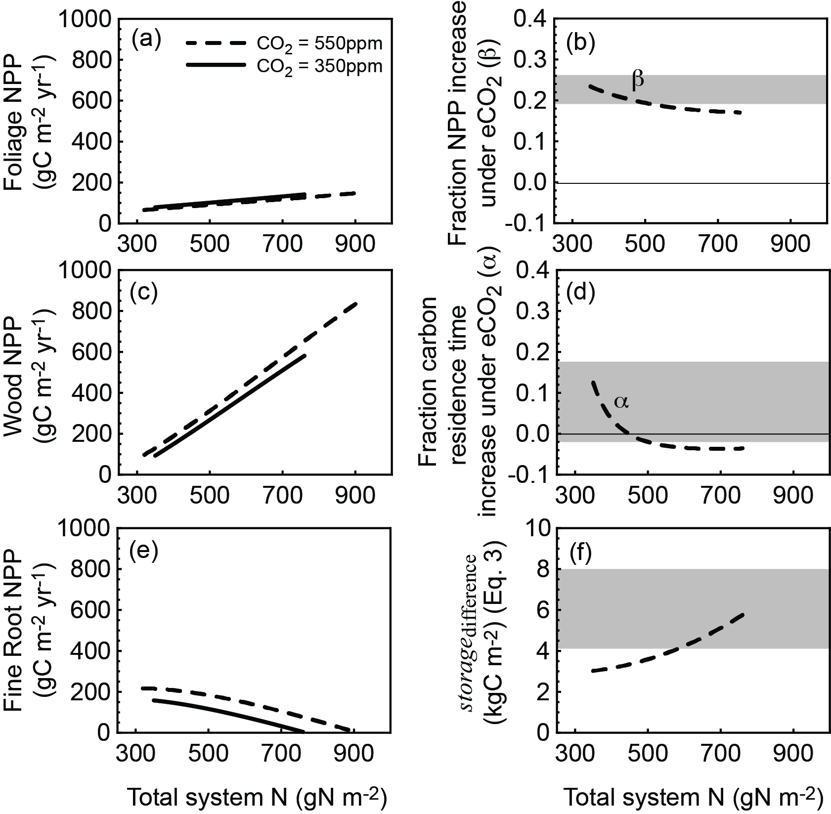

Figure S6. Nitrogen Cycling Model Modification: NPP allocation to foliage (a), wood (c), and fine roots (e) in the modified model is nearly identical to the allocation in the main text model (compare these left-hand panels with the left-hand panels of Fig. 2). However, the small differences cause perceptible decreases in *β* (b), *α* (d), and *storage*difference(f); the shaded areas show the range of values in the main text model (i.e. the ranges in the right-hand panels of Fig. 4).

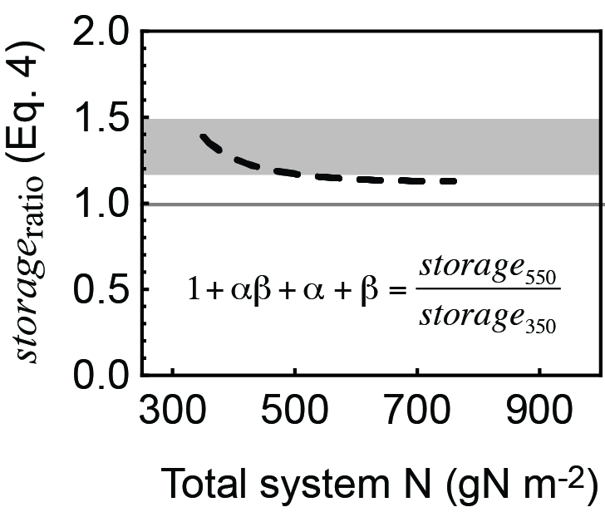

Figure S7. Nitrogen Cycling Model Modification: The ratio of carbon stored under elevated versus ambient CO2 decreases slightly as compared with the main text model; the shaded area shows the range of values in the main text model (i.e. the range in Fig. 5).